Assignment 4
Task 1
- Explored Azure Portal
- Created a Resource Group
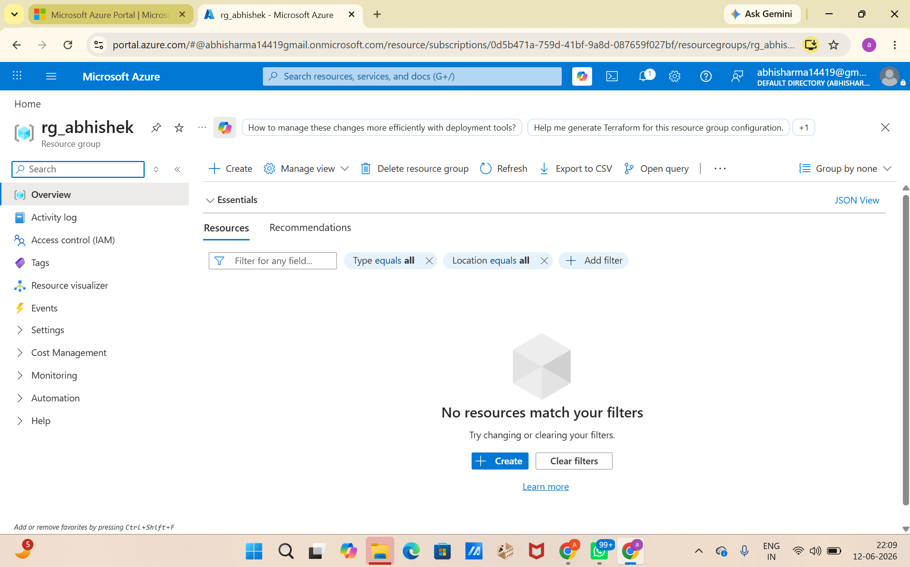

Task 2
- Created a Storage Account Created a Blob Container Uploaded a CSV file
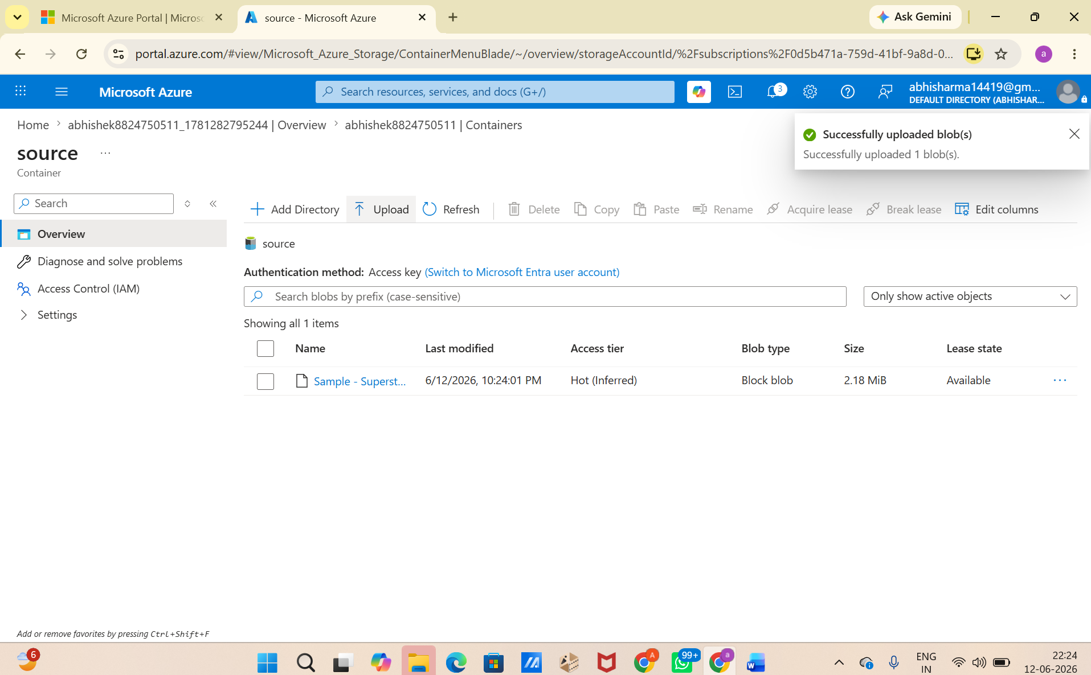

Task 3
- Created Azure Data Factory
- Explored ADF UI (Author, Monitor, Manage)
- Created Linked Service (Blob Storage)
- Created datasets (source + destination)
- Used Get Metadata activity

Deliverable:
- Screenshot of Linked Service
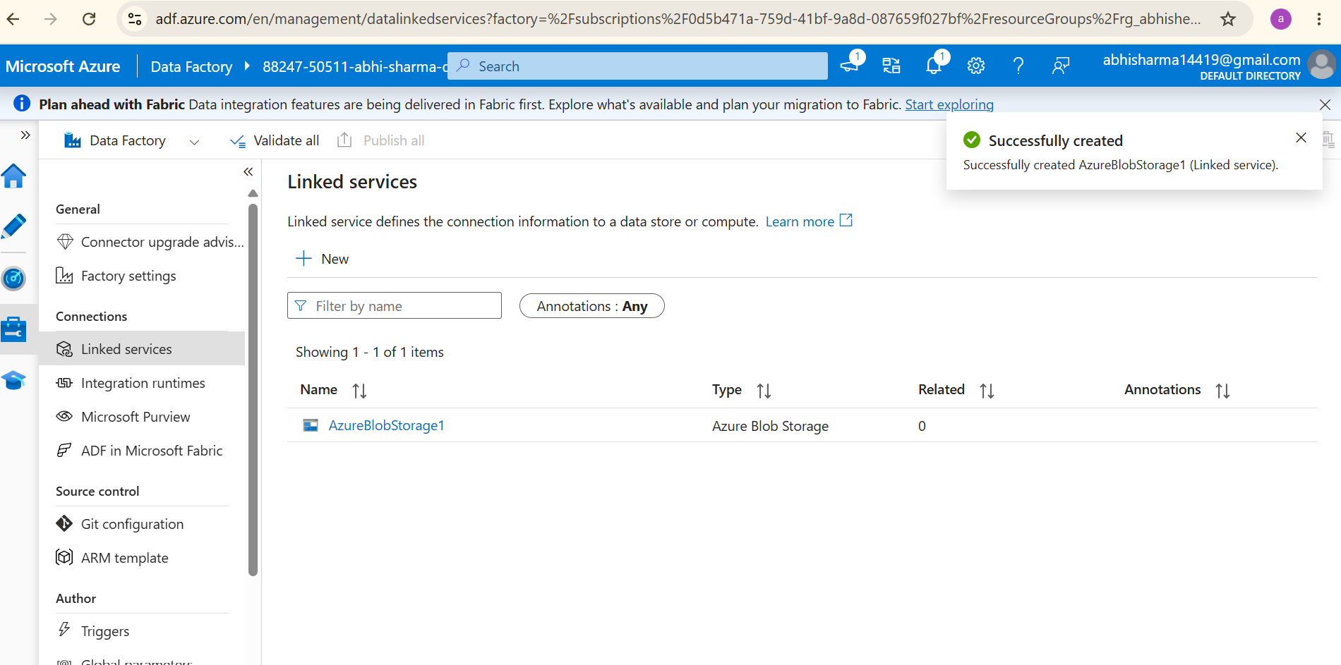

- Screenshot of dataset

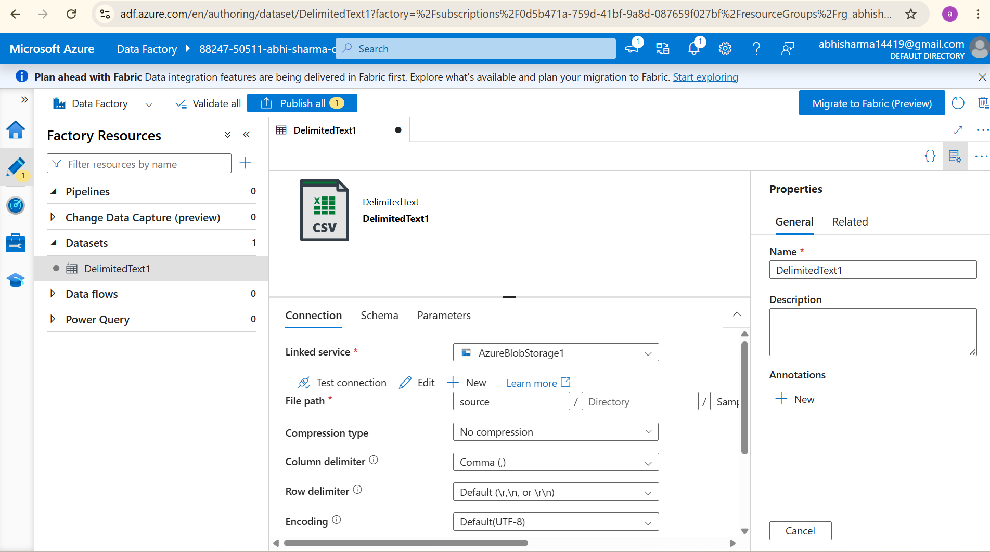

- Screenshot of Get Metadata activity
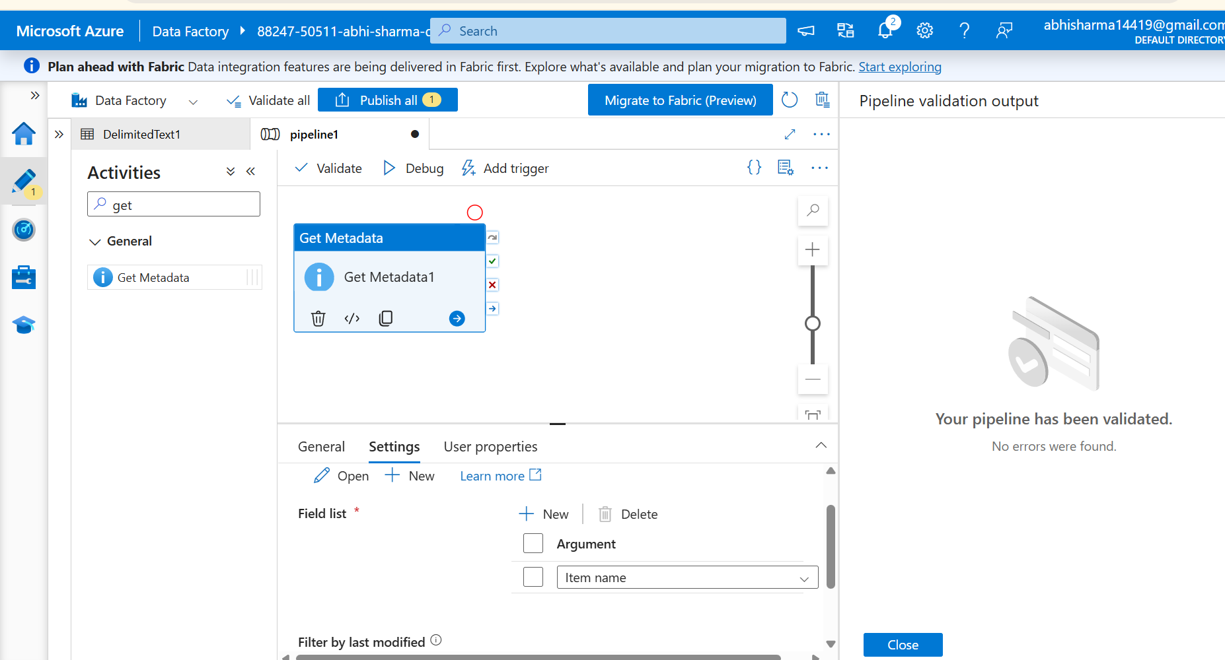

Task 4
- Created pipeline using Copy Data activity
- Configured source and destination
- Added For Each activity

Deliverable:
- Screenshot of pipeline design
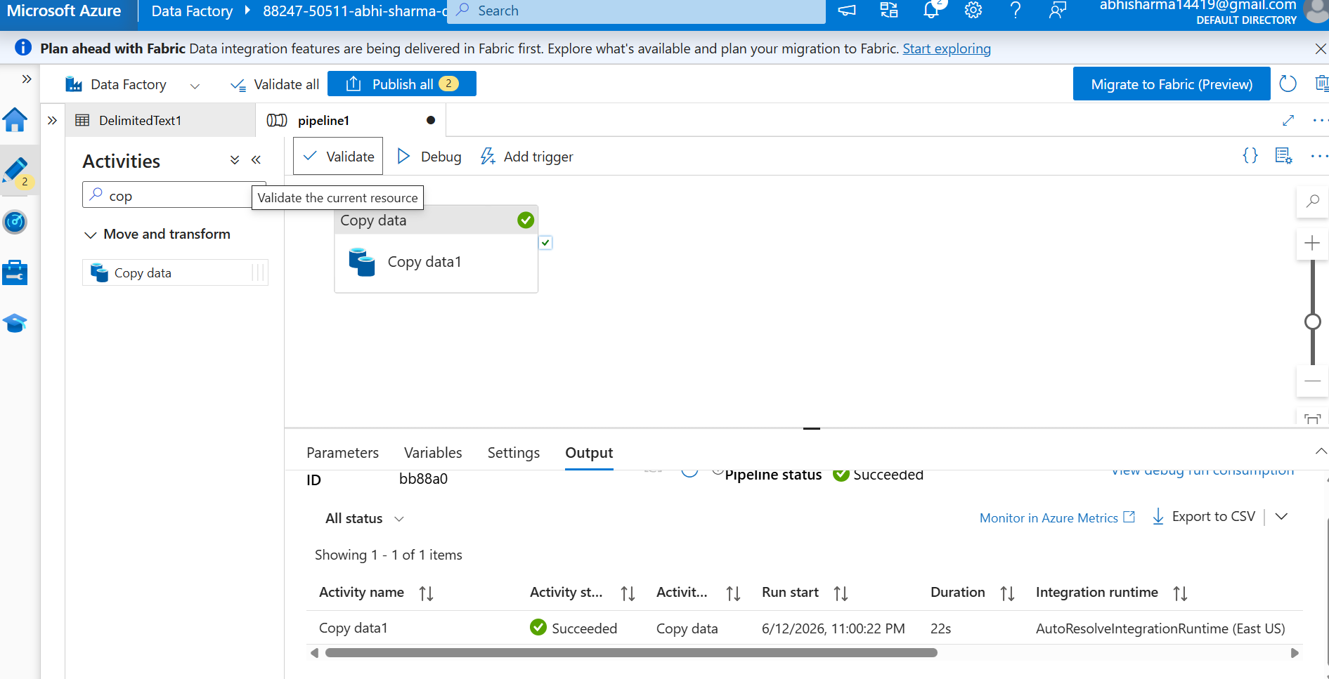

Task 5
- Run pipeline using Debug/Trigger



Task 6
- Assigned roles:
- Reader
- Contributor
- Provided access to ADF for Storage
Deliverable:
- Screenshot of role assignment

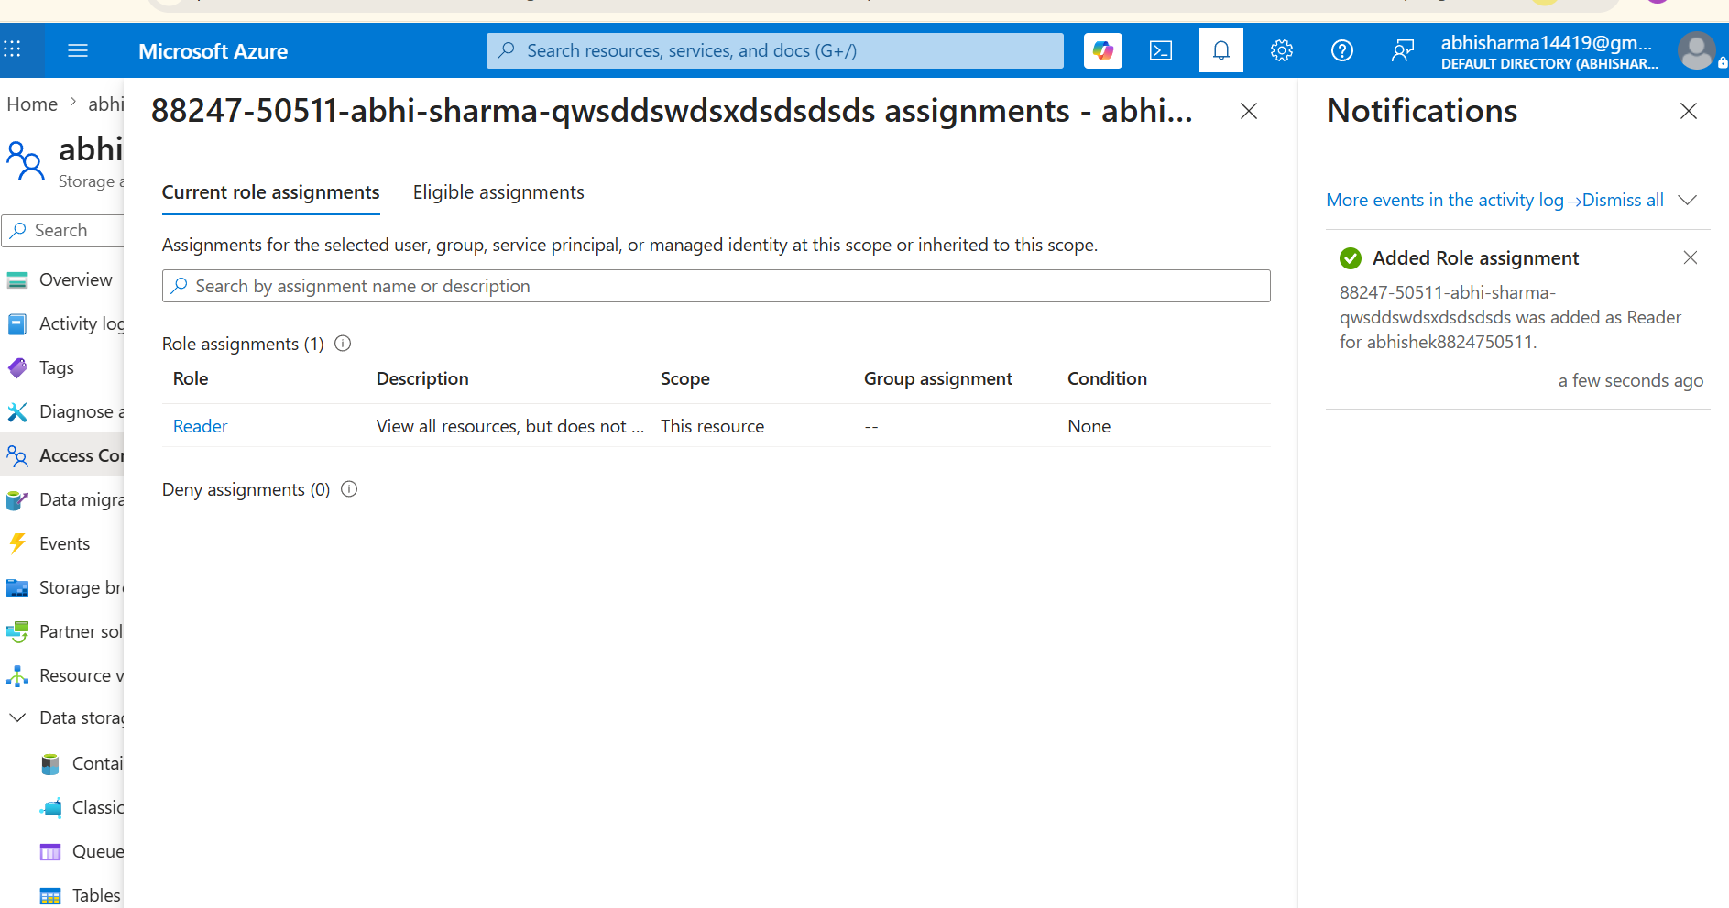

Mini Project-Final Task
Problem Statement:
Build a complete pipeline that reads a CSV file from Blob Storage and processes it using Azure Data Factory.
Requirements:
- Source: CSV file in Blob
- Use: Linked Service + Dataset + Pipeline
- Process: Copy Data + Metadata check
- Destination: New file/location
Expected Output:
- Pipeline executed successfully
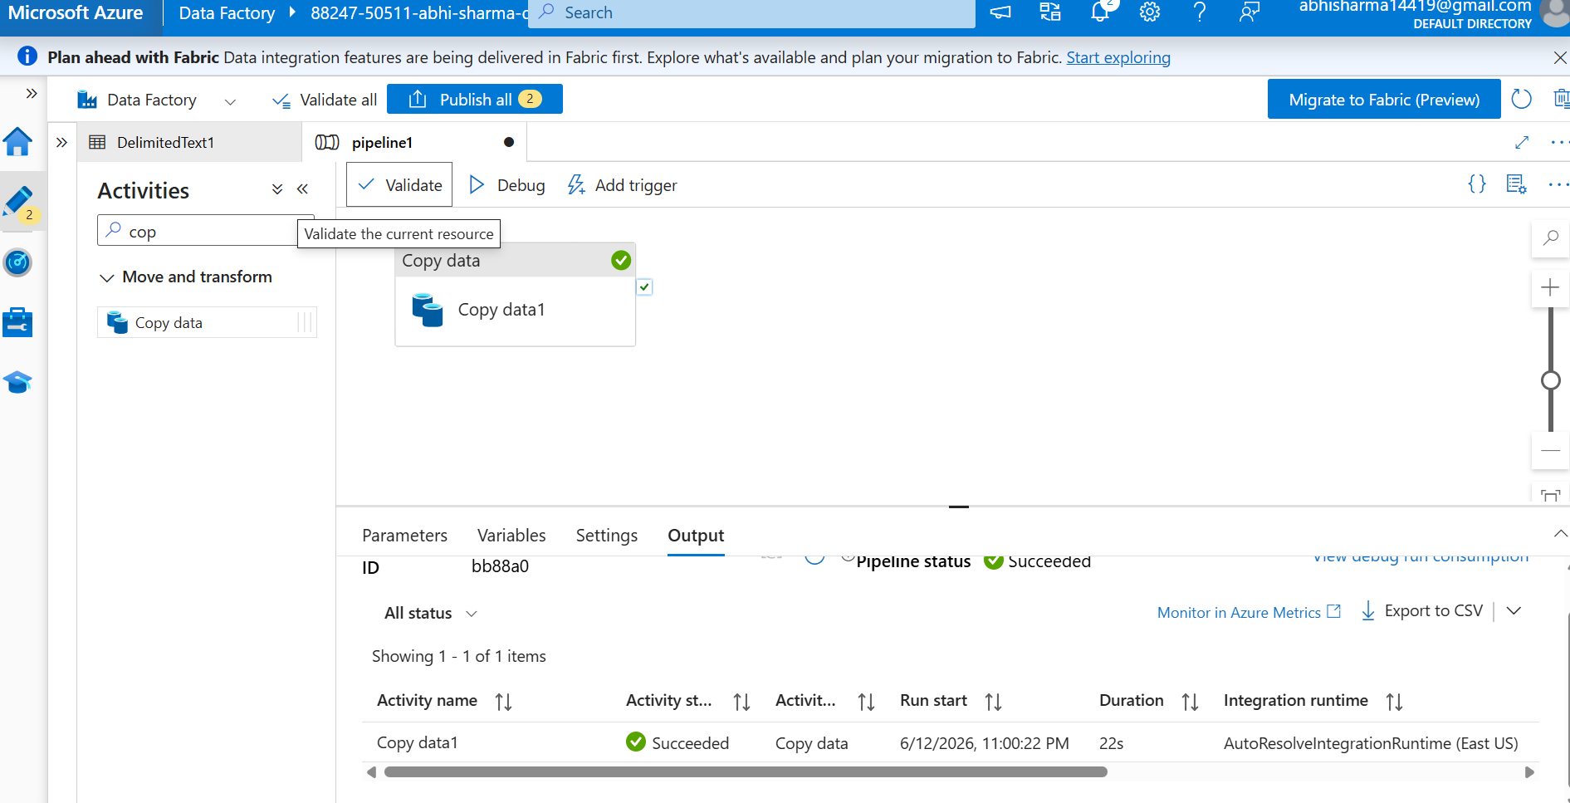

- Data copied to destination
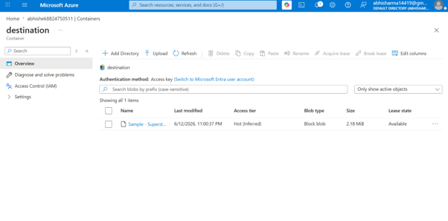

- Metadata validated
